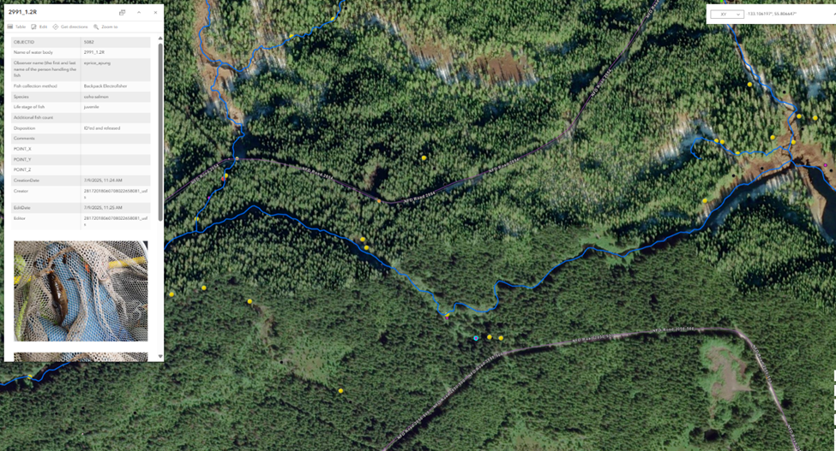
Figure 1. Area map of stream 2991_1.2R tributary of Staney Creek 103-90-10310-2005-3013.

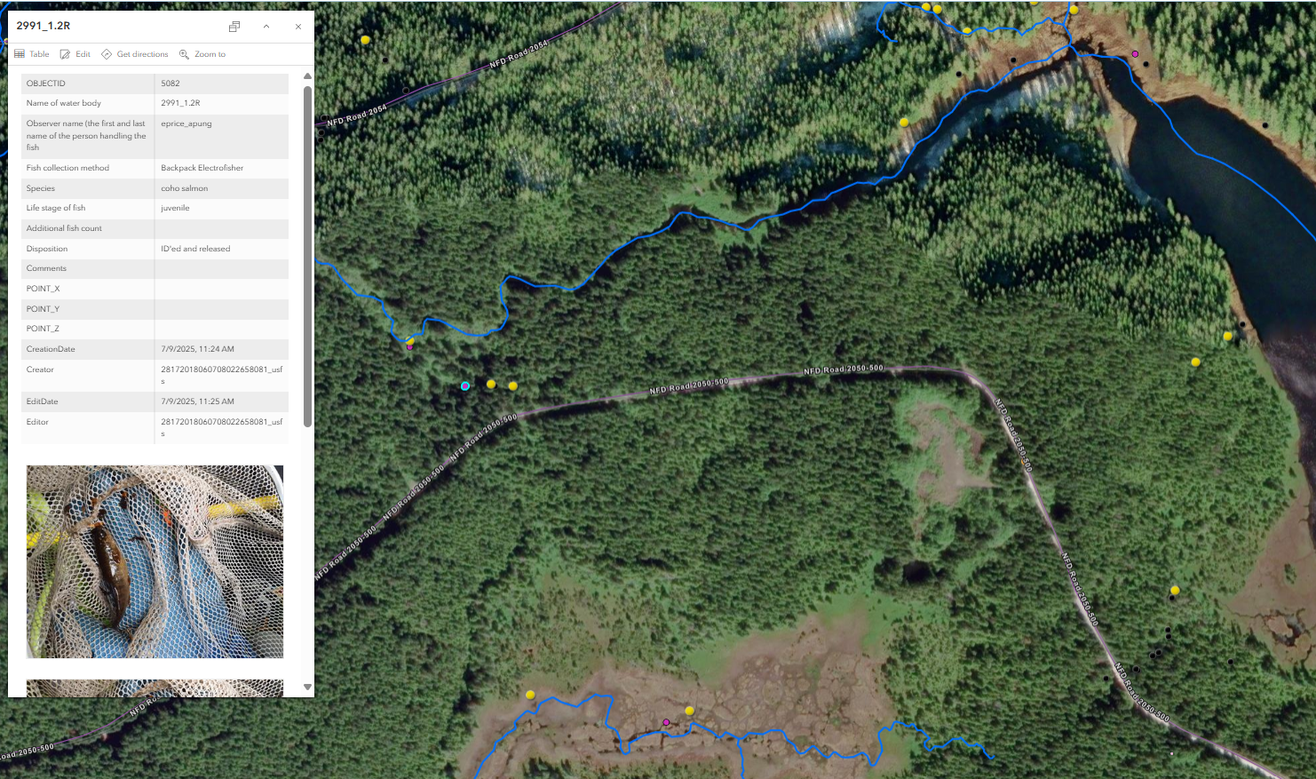
Figure 2. Location map of 1 CO juvenile caught 2991_1.2R. The downstream fish observation point found 5 CO juveniles on 7/9/2025.

